Lab Setup Report
Task-1: Foundations of Cybersecurity Lab Setup Report
Student Name: Hardik Kotawdekar
Offer Letter ID: APSPL2635998
Date: 4 Jun 2026

1. Introduction
This report documents the setup of my cybersecurity lab environment as part of the ApexPlanet Cybersecurity & Ethical Hacking Internship Program. The lab consists of two virtual machines:
- Attacker Machine: Kali Linux
- Target Machine: Metasploitable2
The purpose of this lab is to practice ethical hacking in a safe, isolated environment.

2. Tools & Software Used
- Oracle VirtualBox (Virtualization)
- Kali Linux (Latest version)
- Metasploitable2 (Vulnerable target)
- Host-only Network Adapter

3. Lab Setup Steps
Step 1: Kali Linux Installation
- Installed Kali Linux using ISO file in VirtualBox.
- Allocated 4GB+ RAM and 2+ CPU cores.
- Successfully booted into Kali Linux desktop.
Step 2: Metasploitable2 Setup
- Downloaded Metasploitable2 from SourceForge.
- Created new VM and attached the VMDK file.
- Configured network as Host-only Adapter.
Step 3: Network Configuration
- Created Host-only Adapter in VirtualBox.
- Connected both VMs to the same private network.
- Verified connectivity between Kali and Metasploitable2.

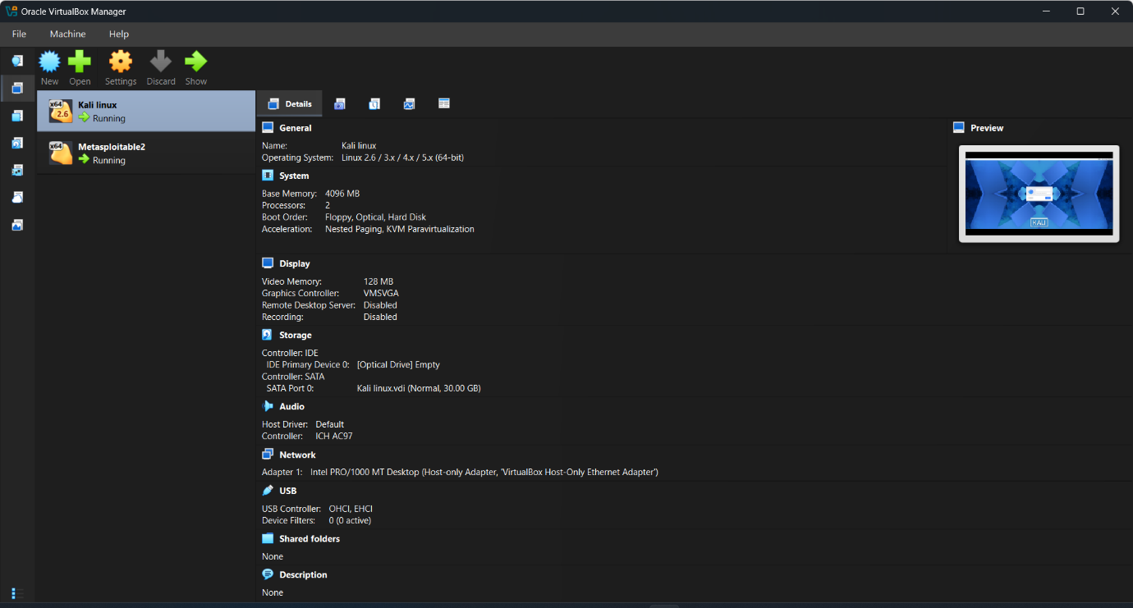
4. Screenshots:

Kali Linux setup screenshot
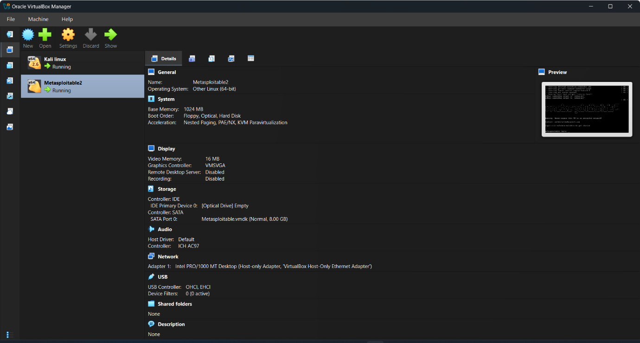

Metasploitable2 setup screenshot

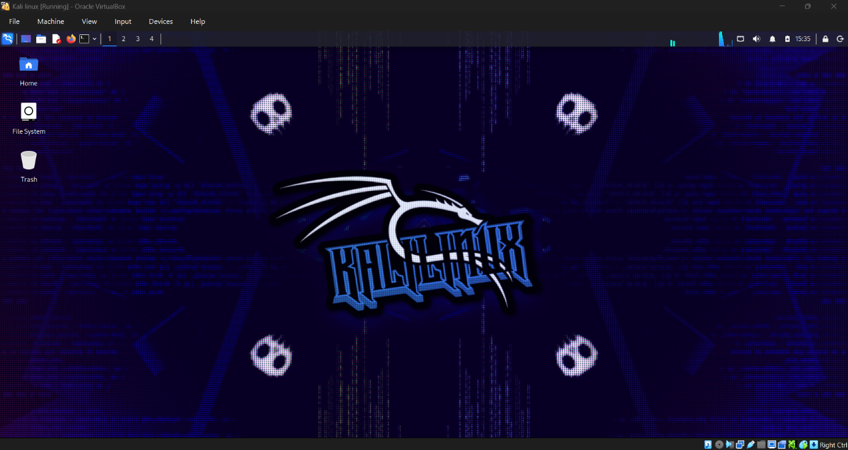

Kali Linux desktop

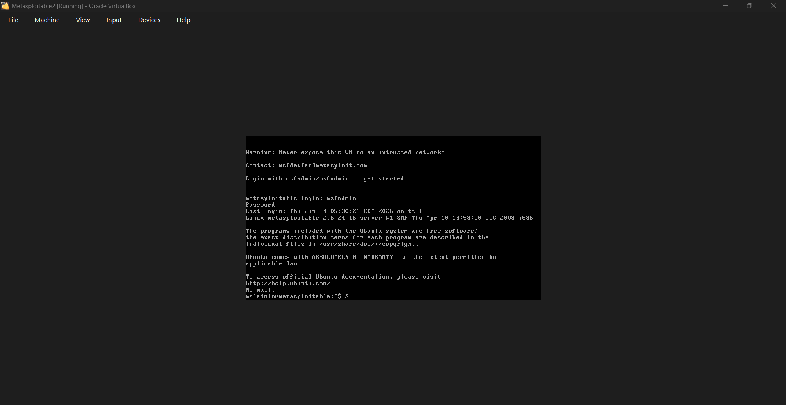

Metaploitable2 CLI
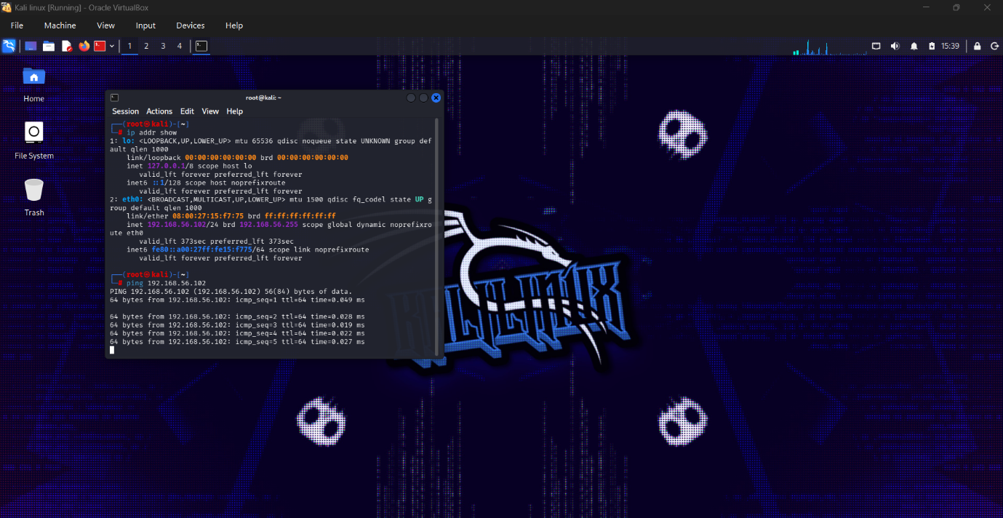

Successful ping between them

5. Conclusion
I have successfully set up a functional cybersecurity lab environment. This setup will be used for performing network scanning, vulnerability assessment, exploitation, and other tasks in the upcoming internship modules.

